**Excel Assignment - 8**

1. What do you mean by AutoComplete feature in Excel and what are the benefits of using this feature?

AutoComplete helps you quickly insert functions and arguments while minimizing typing and syntax errors. The AutoComplete menu shows you available options based on context, and you choose what you want to insert into your formula.

1. **Explain working with workbooks and working with cells.**

### Explore Worksheets

1. Open Excel and open a new Blank workbook.
2. The workbook opens with one worksheet called Sheet1. This worksheet contains cells you can use to start entering and editing data.
3. [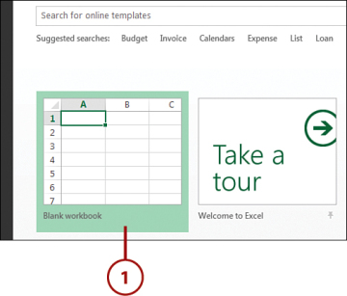](javascript:popUp('/content/images/chap1_9780789750754/elementLinks/01fig09_alt.jpg'))Click the plus icon to add a new worksheet

**Explore Columns, Rows, and Cells**

1. Click the column reference and observe how the entire column is selected.
2. Click the row reference and observe how the entire row is slected.

[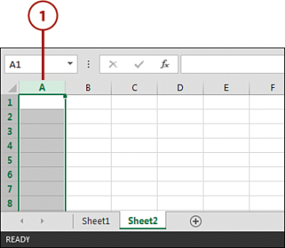](javascript:popUp('/content/images/chap1_9780789750754/elementLinks/01fig12_alt.jpg'))

1. **What is fill handle in Excel and why do we use it?**

You can quickly copy formulas into adjacent cells by using the fill handle.

Fill handle

When you drag the handle to other cells, Excel will show different results for each cell.

1. **Give some examples of using the fill handle.**

* Select the cell that has the formula you want to fill into adjacent cells.
* Rest your cursor in the lower-right corner so that it turns into a plus sign (+), like this:
* 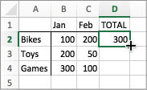
* Drag the fill handle down, up, or across the cells that you want to fill. In this example, the figure here shows dragging the fill handle down:
* 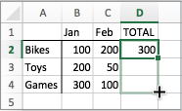
* When you let go, the formula gets automatically filled to the other cells:
* 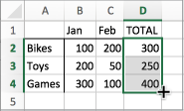
* To change how you want to fill cells, click the **Auto Fill Options** button  that appears after you finish dragging, and pick the option that want.

1. **Describe flash fill and what the different ways to access the flash fill are.**

Enter the full name in cell C2, and press **ENTER**.

Start typing the next full name in cell C3. Excel will sense the pattern you provide, and show you a preview of the rest of the column filled in with your combined text.

To accept the preview, press **ENTER**.

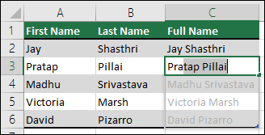

If Flash Fill doesn't generate the preview, it might not be turned on. You can go to **Data** > **Flash Fill** to run it manually, or press Ctrl+E. To turn Flash Fill on, go to **Tools** > **Options** > **Advanced** >**Editing Options** > check the **Automatically Flash Fill** box.

6. **Extract first name and last name from the mail id and then from the address column, extract the city, state, and pin code using the flash fill. Given below is an example of the columns you have to create.**

**Paste the screenshot of what you have created using the flash fill command. Example: Mail Id, Address, First name, Last name, State, City, Pincode**